A Mini Project Report

On

“Anaemia Prediction Model using Explainable AI”
submitted in partial fulfilment of the requirements for the award of degree of

Bachelor of Engineering
In
Computer Science and Engineering
Submitted by

Eshwar Tej Ganji 1608-23-733-160
Clyton Erastus Basipaka 1608-23-733-173
Mohammed Muddabir Ahsan 1608-23-733-176

Under the Guidance of
Dr. L Raghavendra Raju
Associate HoD

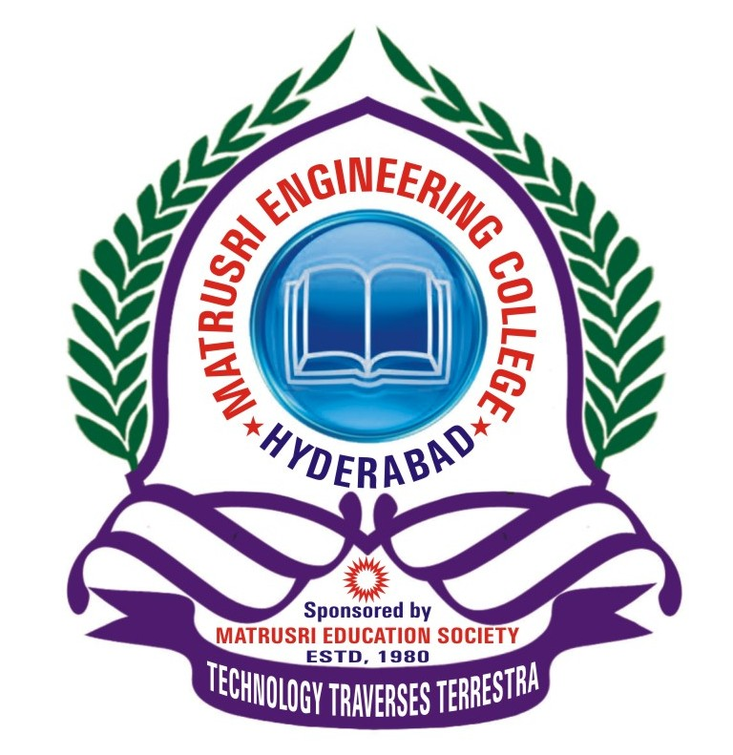

Department of Computer Science and Engineering
Matrusri Engineering College
(Affiliated to Osmania University, Approved by AICTE)
Saidabad, Hyderabad - 500059
(2025-2026)
Department of Computer Science and Engineering
Matrusri Engineering College
(Affiliated to Osmania University, Approved by AICTE)
Saidabad, Hyderabad - 500059


CERTIFICATE
This is to Certify that A Mini Project report entitled “Anaemia Prediction Model using Explainable AI” is being submitted by Eshwar Tej G (1608-23-733-160), Mohammed Muddabir Ahsan (1608-23-733-176), Clyton Erastus B (1608-23-733-173) in partial fulfilment of the requirement of the award for the degree of Bachelor of Engineering in “Computer Science and Engineering” O.U., Hyderabad during the year 2025-26 is a record of Bonafide work carried out by him/her under my guidance. The results presented in this mini project report have been verified and are found to be satisfactory.

Project Guide HOD

Dr. L Raghavendra Raju Dr. T.Raghunadha Reddy
Associate HoD Assoc. Professor & Head Dept. of CSE Dept. of CSE

External Examiner(s):____________________________________

ACKNOWLEDGEMENT

It is our privilege and pleasure to express our profound sense of respect, gratitude and indebtedness to our guide Mr. Dr. L Raghavendra Raju, Associate HoD, Department of Computer Science and Engineering, Matrusri Engineering College, for his indefatigable inspiration, guidance, cogent discussion, constructive criticisms and encouragement throughout this dissertation work.

We express our sincere thanks to mini project coordinator Mrs. K. BhagyaLaxmi, Assistant professor and Ms Rama Lakshmi, Assistant Professor, Department of Computer Science and Engineering, Matrusri Engineering College, for her valuable suggestions and constant help in completing the work.

We express our sincere gratitude to Dr. T.Raghunadha Reddy, Associate Professor & Head, Department of Computer Science and Engineering, Matrusri Engineering College, for his precious suggestions, motivation and co-operation.

We extend our sincere thanks to Dr. G.Amarendar Rao, Principal, Matrusri Engineering College, Saidabad, Hyderabad, for his encouragement and constant help.

We extend our sincere thanks to all the teaching and non-teaching staff of CSE Department for their support and encouragement.

Last but not least, we wish to acknowledge our friends and family members for giving moral strength and helping us to complete this dissertation.

